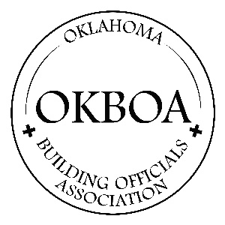

OKBOA General Membership Application

Please fill this form out and email it back to contact@okboa.com if you are interested in becoming a member.

First and Last Name:
Mailing Address:
Contact Phone:
Contact E-mail:
Jurisdiction or Company name:

Are You currently working as a building code inspector and/or plans examiner:

Do you currently have an Oklahoma active building inspector’s state license:

Do you have any active or expired building code ICC Certifications:

Thank You for your interest in joining other professional building code officials in being part of furthering and developing our industry for the life, safety and protection of the citizens of the state of Oklahoma.

